Wroclaw, Poland, September 17th 2024

**SOUTHERN POLAND UNDER WATER - AN APPEAL FOR HELP!**

**Casualties, the evacuation of people, a state of natural disaster - southern Poland is struggling with a devastating flood. Dramatic rescue and evacuation operations are underway in many towns and cities. More are expected to be flooded and evacuated. Help is desperately needed to support the Polish Red Cross's crowdfunding campaign.**

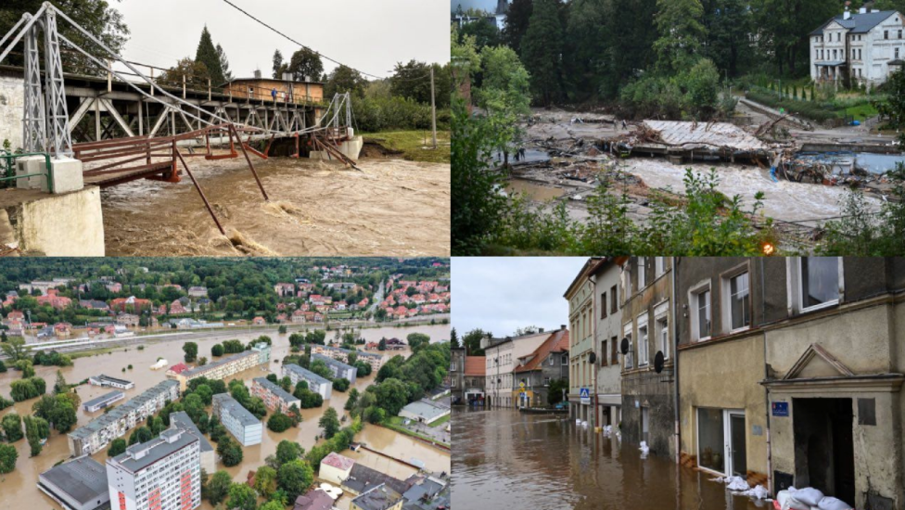

*Poland is devastated by a flowing natural disaster*

South-western Poland was flooded on September 14-16, 2024, with the most dramatic situation in the Dolny Slask and Opolskie regions. The situation is developing minute by minute as rivers are rising rapidly, and intense rainfall is expected to continue over the next few days, leading to even greater destruction according to local authorities.

A dam in the town of Stronie Slaskie was breached by the floods, and a temporary bridge in Glucholazy was destroyed. Stronie Slaskie and Ladek Zdroj are virtually cut off from the world and the town of Klodzko is completely under water. A hospital in Nysa had to evacuate its patients, including pregnant women and children.

According to experts, almost 1/3 of Poland is at risk of flooding, as shown on the map below.

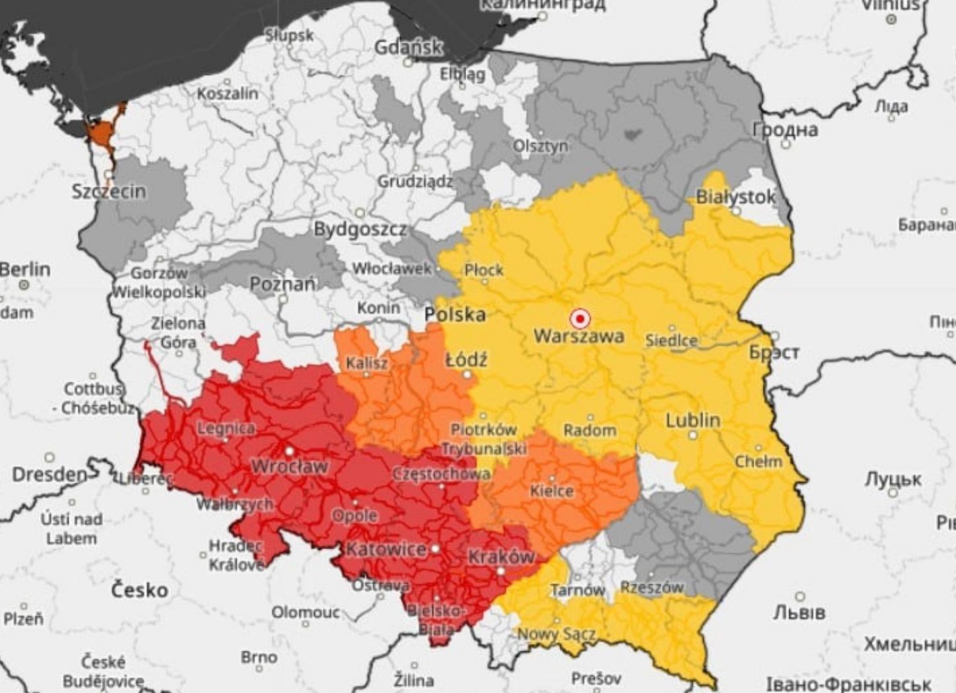

*The areas marked in red are currently most likely to get flooded*

**Dramatic situation in many places**

Donald Tusk, the Polish prime minister, has described the situation in the south-western part of the country as dramatic, as local rivers broke record high levels, causing flooding in several municipalities after days of heavy rainfall.

"The situation is very dramatic, it's the most dramatic in the Klodzko Valley, in Klodzko county, south-western Poland," Tusk told reporters on Sunday, September 15th, after meeting with the crisis management team in the town of Klodzko.

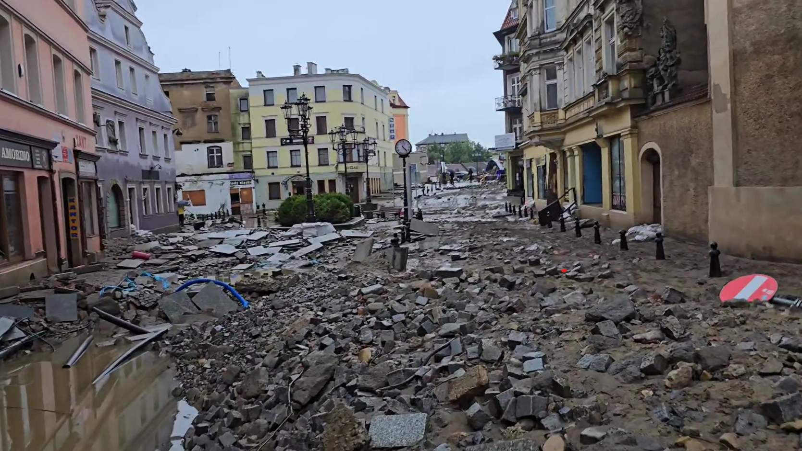

*The market square of the old town of Klodzko after the passage of the floods last weekend*

Many households in the Klodzko county were left without power and mobile connections were not available in some areas. Road access to the towns of Ladek Zdroj and Stronie Slaskie was practically cut off.

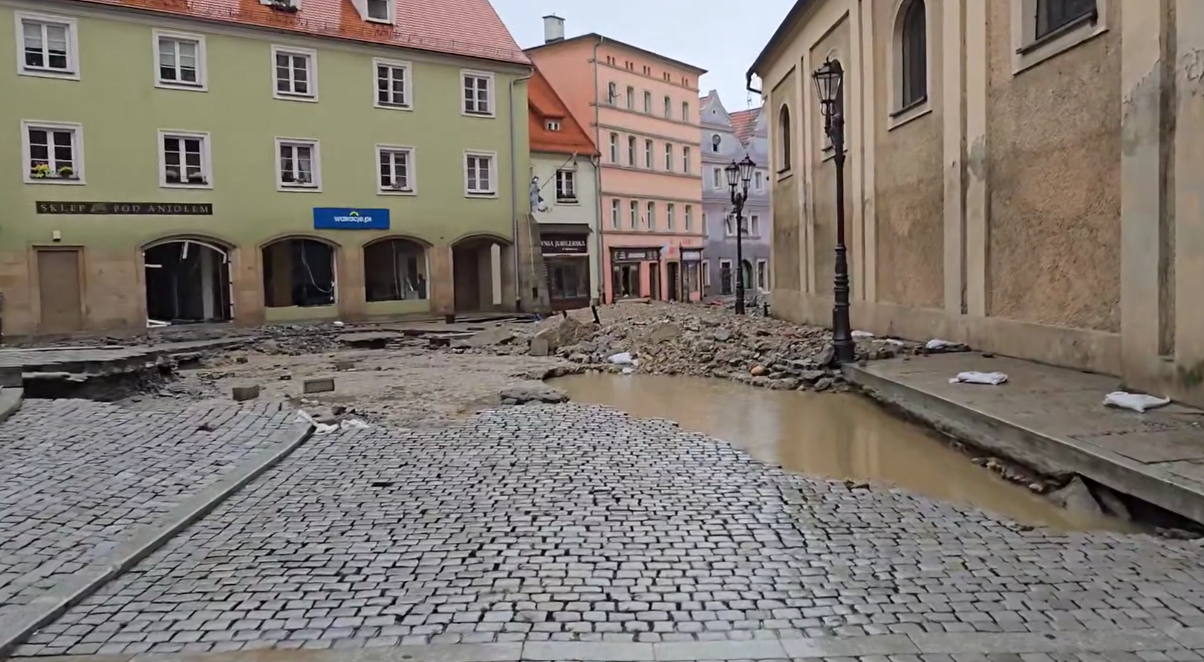

*The market square of the old town of Klodzko after the passage of the floods last weekend*

**Wroclaw, Opole, Olawa are getting ready for armageddon**

Wroclaw, Poland's third largest city, is preparing for the impact of the flood wave, which is expected to hit this Wednesday, September 18, around 6 pm. The mayor of Wroclaw, Jacek Sutryk, issued a flood alert for Wroclaw on Sunday night, September 15. According to the latest forecast, the Oder River in Trestno, near Wroclaw, will rise to 698 centimeters on Wednesday. The authorities will also raise the dikes in Kozanow and Opatowice. Meanwhile, an evacuation order was issued in Olawa on Monday morning.

Smaller towns and cities in the Dolny Slask and Opolskie regions, such as Opole, Olawa and Brzeg, are also preparing for the floods, and they need help, too.

**To the rescue**

In the face of the floods, the Polish Red Cross, together with the zrzutka.pl and 4fund.com platforms, is organizing a charity campaign in support of flood victims **#EmergencyFloodRelief**.

The Polish Red Cross, in collaboration with local crisis management teams, rescue services, and municipalities, is already preparing to provide aid to the most affected areas. We are organizing a fundraiser to collect funds that will be immediately used to purchase essential supplies and equipment. Among the top priorities is ensuring that those affected receive:

**Food Packages:** In the first phase of the relief effort, delivering food packages to individuals evacuated from the danger zones will be crucial.

**Drinking Water:** Damage to water infrastructure and contamination of water sources are common consequences of flooding. The Polish Red Cross is already preparing supplies of drinking water to be delivered where local sources have ceased to function.

**Hygiene Kits:** Flooding also brings a significant sanitary threat. The water flooding these areas is often contaminated, increasing the risk of disease. The Polish Red Cross is planning to provide hygiene kits, including cleaning agents, disinfectants, and essential hygiene products.

**Dehumidifiers:** After the emergency response phase, dehumidifying flooded buildings will be essential. Funds from this campaign will enable the purchase of dehumidifiers, which will help restore livable conditions for residents once the water levels recede.

Every contribution, no matter how small, makes a significant difference and can profoundly impact the lives of those who need it most right now. Join us in this mission to bring relief to those who need it the most. Your support can help turn this challenging time into a slightly more manageable situation.

**Interested in helping? Please visit<https://4fund.com/flood>**

***

**About 4fund.com**

4fund is a platform designed for creating online fundraisers for any purpose, such as gifts, trips, businesses, and charitable actions. Using 4fund.com is completely free; the portal does not charge any fees for contributions, withdrawals, or commissions, and it offers convenient deposit options including payment by card, Apple Pay, or Google Pay. Users can create one-off campaigns or collect regular contributions for a project or business. 4fund.com boasts 813,000 registered users, 1.2 million fundraisers, and nearly €300 million total donations paid to various types of projects on the platform. The platform has been operational for over 10 years and is a licensed payment services provider in the European Union, regulated by the Polish Financial Supervision Authority (UKNF).